The Simple View of Reading (SVR)

(Gough and Tumner – since 1986)

Decoding x Linguistic (Language) Comprehension = Reading Comprehension

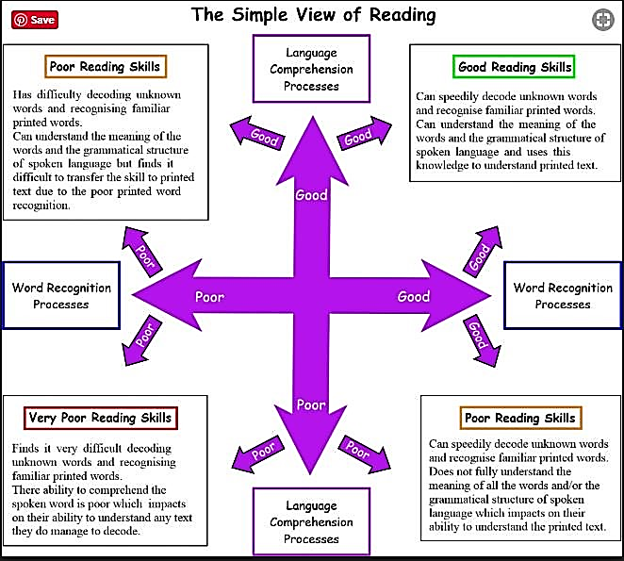

Scarborough’s Reading Rope
(Scarborough – since 2001)

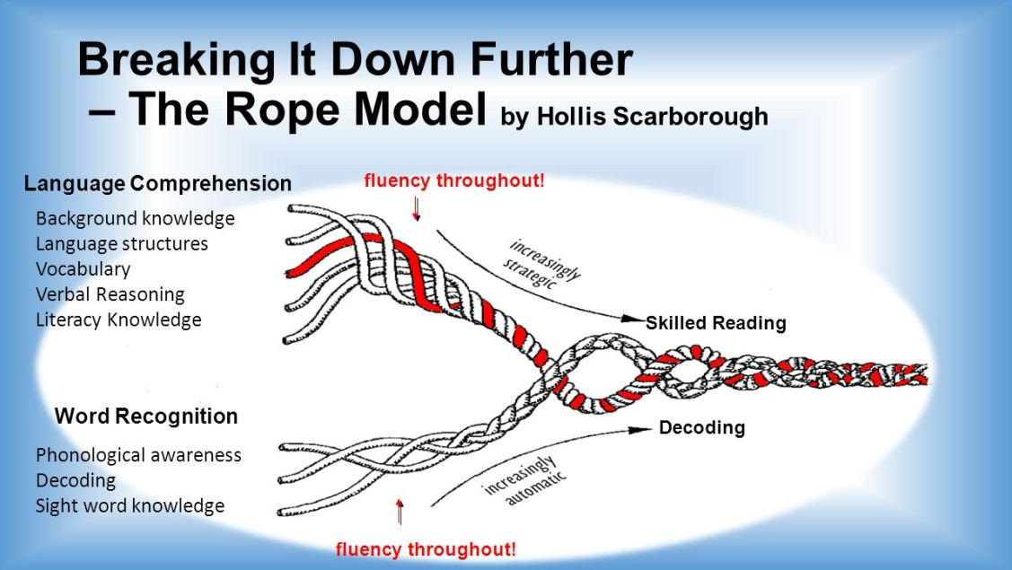
The Big 6 (Pillars of Reading)

Motivation / Engagement | Phonemic Awareness
Phonics | Fluency
Vocabulary | Comprehension

