The Science of Reading and Reading Instruction

SIMPLE VIEW OF READING

READING COMPREHENSION = X

(“LC” NOT = listening)

High- Low High- High

Low – Low High- Low

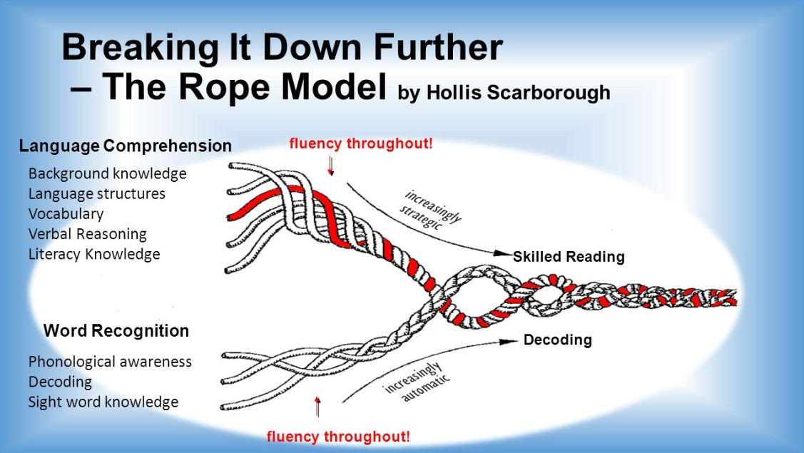

5 PILLARS OF READING

PHONEMIC AWARENESS
Blue or White sheet with phonemic awareness activities at various levels

PHONICS

- How many sounds can the grapheme <ou> represent?

- How many graphemes (letters or letter groups) can you think of that can represent the sound /s/ (which you hear at the beginning of the word

Polysyllabic Words for Decoding

glomerulonephritis

triphosphopyridine

pachycephalosaurus

nephroangiosclerosis

sternocleidomastoid

hydrochlorofluorocarbon

uvulopalatopharyngoplasty
glomerulonephritis
18 Letters
11 Consonants (including 1 digraph)
7 Vowel Sounds 7 Vowel Letters
7 Syllables

triphosphopyridine
18 Letters
12 Consonants
6 Vowel Sounds 6 Vowel Letters (including ,<y>)
6 Syllables

pachycephalosaurus
18 Letters
11 Consonants (including 2 digraphs)
7 Vowel Sounds 8 Vowel Letters
7 Syllables

nephroangiosclerosis
20 Letters
12 Consonants (including 1 digraph)
8 Vowel Sounds 8 Vowel Letters
7 Syllables

sternocleidomastoid
19 Letters
11 Consonants
6 Vowel Sounds 8 Vowel Letters
6 Syllables

hydrochlorofluorocarbon
23 Letters
15 Consonants
9 Vowel Letters 8 Vowel Sounds
8 Syllables

uvulopalatopharyngoplasty
25 Letters
16 Consonants
11 Vowels
11 Syllables

DECODING

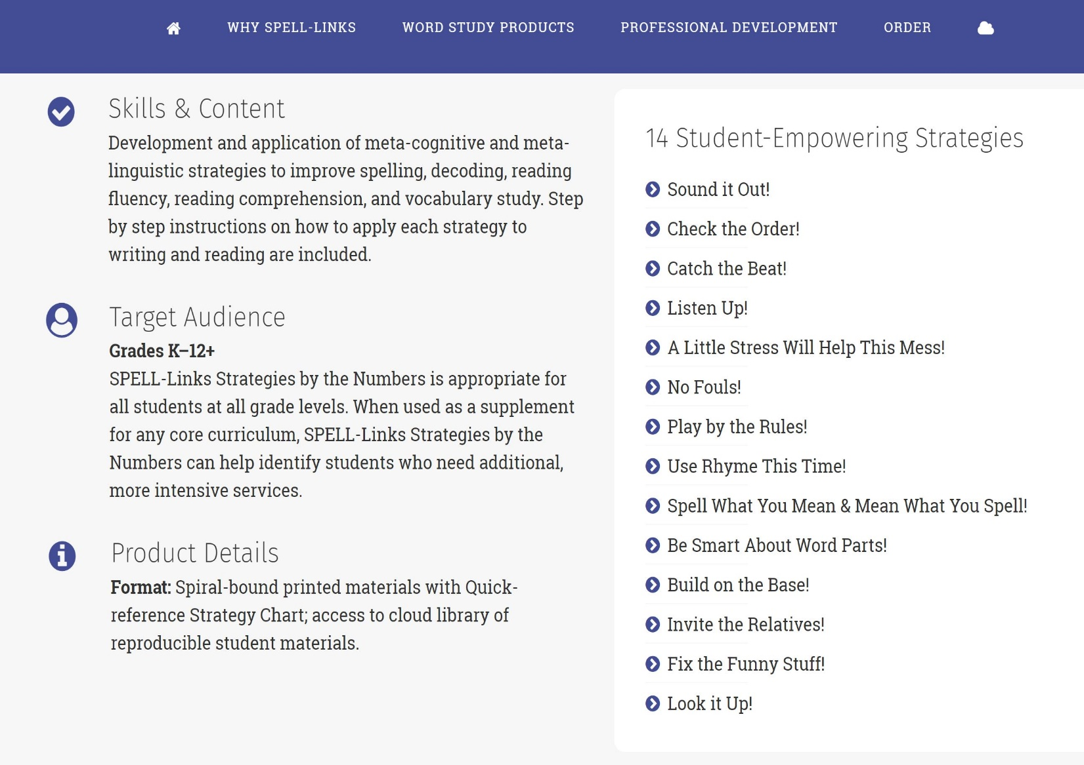

https://learningbydesign.com/word-study-products/instruction/strategies-by-the-numbers/

FLUENCY

FLUENCY is the BRIDGE BETWEEN and

The correlation between fluency and comprehension is ?

Dynamic Indicators of Basic Early Literacy Skills (DIBELS)
Letter Naming Fluency (but parents can work or Letter-Sound Naming Fluency)

Phoneme Segmentation Fluency

Nonsense Word Fluency

Word Reading Fluency

Oral Reading Fluency

